Project Design Document

1. Design Intent
The project aims to create an interactive, immersive experience where the user engages with a physical-digital puzzle system inspired by the idea of an Egyptian Sphinx that tests intelligence and decision-making. The experience is designed to feel slightly tense and consequential, where each choice matters and progression is earned gradually. The combination of physical feedback (LEDs, servo movement) and a digital interface (web-based riddles) creates a layered interaction that blends game, installation, and object.
The primary audience for this experience is young adults or anyone who is drawn to interactive installations and puzzle-based challenges. It is intended to be experienced individually, reinforcing a sense of personal responsibility and consequence in decision-making.
The aim of the project is not to solve a specific real-world problem, but to create an engaging and enjoyable game experience that challenges the user’s thinking. It focuses on encouraging players to use their brain through riddles and decision-making, while maintaining a sense of tension and progression. The design prioritizes making the interaction fun, immersive, and mentally stimulating, where players feel rewarded for thinking carefully and making the right choices.

2. Inspiration & References
The project draws inspiration from a combination of mythology, interactive games, and physical installations. The concept of the Sphinx is taken from Egyptian mythology, where it is known for guarding spaces and presenting riddles that test intelligence. This idea of a gatekeeper that challenges the user before granting access directly influenced the core interaction of the project.
Interactive quiz systems and escape-room style experiences also served as references. These systems often combine problem-solving with time pressure and consequence, creating a sense of urgency and engagement. From these, the idea of limited chances and progression-based feedback (through LEDs and stages) was developed.
Digitally, web-based quiz interfaces and simple game UIs influenced the structure of the interface. The decision to keep the UI minimal came from observing that overly complex visuals can distract from the core interaction, while simple layouts keep the focus on the questions and user decisions.
From these references, the key learning was that constraint increases engagement. Systems that limit retries, provide clear feedback, and tie actions to physical consequences (like a door opening) create a stronger emotional response. Additionally, combining physical outputs with digital inputs makes the experience feel more real and immersive compared to purely screen-based interactions.

3. User Journey
-User approaches the setup
The user notices a physical Sphinx structure. As they move closer, the system detects their presence through the ultrasonic sensor, creating a sense of being “noticed” or acknowledged.
-System activates
The interface on the connected device (phone/laptop) automatically becomes active through wifi, indicating that the challenge has begun. The user understands that they are about to be tested.
-User begins interaction
The first riddle appears on the screen. The user reads the question and possible answers, then selects their response by touching one of the capacitive touch wires (A/B/C/D).
-System provides feedback
The system immediately responds with sound and light. A correct answer triggers a positive beep and LED feedback (blinking or lighting up), while a wrong answer triggers a different sound. At the same time, the Sphinx nods its head in disapproval for every wrong answer, making the interaction feel more alive and reactive.
-Progression through stages
The user continues answering questions in pairs. For early stages, even one correct answer allows progression, building confidence. In later stages, both answers must be correct, increasing difficulty and pressure. LEDs reflect this progression.
-Building tension
As the user progresses, the lighting feedback accumulates, and the stakes feel higher. The limited chances make the user more cautious and engaged with each decision.
-Outcome: Win or Lose
- If the user succeeds, the final LEDs confirm completion, the door mechanism slowly opens, and the NeoPixel strip lights up in colorful patterns, creating a celebratory moment.
- If the user fails, the system stops immediately, the Sphinx nods in response to the mistake, and a “Game Over” message is displayed with no further interaction allowed.

4. Success Criteria
Functional
- System detects user presence and starts the game within 1–2 seconds
- Touch inputs are registered accurately with minimal false triggers
- LEDs respond instantly (<1 second) to correct answers and reflect progression correctly
- Servo motor (door) activates only upon winning and performs smooth, controlled motion
- Sphinx head responds to wrong answers consistently through nodding motion
- NeoPixel strip displays clear color feedback and animation upon winning
- Web interface updates in real-time with correct question, score, and feedback
User Experience
- Interaction is intuitive, with users easily understanding how to answer using touch inputs
- Feedback (light, sound, motion) clearly communicates correct vs wrong answers
- Progression system feels engaging, with increasing challenge and visible advancement
- The experience maintains a sense of tension and consequence without confusing the user
- The interface is simple and easy to read, keeping focus on the riddles
Reliability
- System runs continuously without crashing or freezing during gameplay
- Touch sensors remain stable and do not produce frequent errors or false readings
- Ultrasonic sensor consistently detects presence without random triggers
- All hardware components (LEDs, servos, buzzer, NeoPixels) perform consistently across multiple tests
- Game logic correctly handles win/lose conditions without allowing unintended restarts

5. System Overview
This project is an interactive physical-digital game system built around a central microcontroller (ESP32) that connects sensors, outputs, and a web-based interface. The system detects a user’s presence, presents riddles through a browser interface, receives input through touch sensors, and responds with physical feedback such as lights, sound, and motion. The overall experience is designed to feel like a responsive, intelligent object that challenges the user and reacts to their performance.
The system works by combining input → processing → output:
- Inputs (ultrasonic sensor and touch pads) capture user actions
- The ESP32 processes game logic and decision-making
- Outputs (LEDs, servo motors, buzzer, NeoPixels, and web UI) provide feedback
Main Parts of the System:
- ESP32 Microcontroller
Acts as the brain of the system. It runs the game logic, handles WiFi communication, processes sensor inputs, and controls all outputs.
- Input Components
  - Ultrasonic Sensor: Detects when a user approaches and triggers the start of the game
  - Capacitive Touch Sensors (A/B/C/D wires): Used by the user to select answers
- Output Components
  - LEDs (Progress Indicators): Show progression through the game stages
  - Servo Motors:
    - One controls the Sphinx head (nodding on wrong answers)
    - One controls the door mechanism (opens when the user wins)
  - Buzzer: Provides audio feedback for correct and incorrect answers
  - NeoPixel Strip: Displays colored lighting effects, especially as a reward when the user wins
- Web Interface (UI)
A simple browser-based interface hosted by the ESP32. It displays riddles, answer options, score, and game state in real time.
- Physical Structure
The enclosure made of cardboard and foam board houses all components, with a 3D-printed Sphinx acting as the central visual and interactive element.

6. High-Level Block Diagram
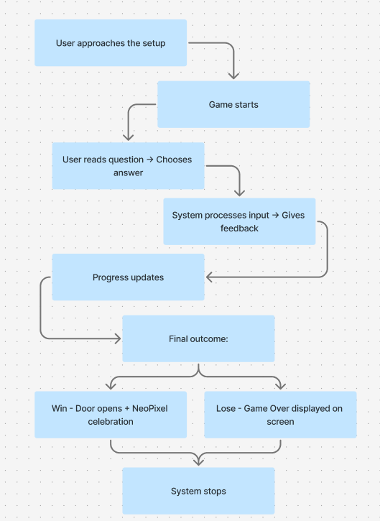

7. Input / Output Mapping
Input | Process | Output
User approaches (Ultrasonic sensor) | Detect distance - start game | Game begins on web interface once to connect to the wifi
Touch input (A/B/C/D) | Read touch values - compare with correct answer | Neopixel shows if the answers are correct or wrong( for correct- the led lights up, for wrong- the sphinx nods head )
Answer result | Update score + pair logic evaluation | LED progress update
Wrong answer | Trigger feedback function | Buzzer sound + Sphinx head nod
Correct answer | Increment progress | Green light + positive sound
Pair completion (2 questions) | Check pass condition (1/2 or 2/2) | LED lights up / Game ends if failed
Game win condition | Check 4 LEDs completed | Door opens + NeoPixel rainbow
Game loss condition | Wrong answers / failed pair | Game Over displayed on website

8. Sketches & Concepts
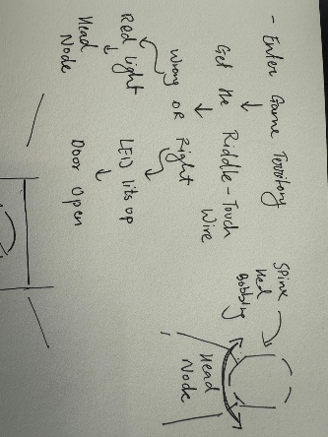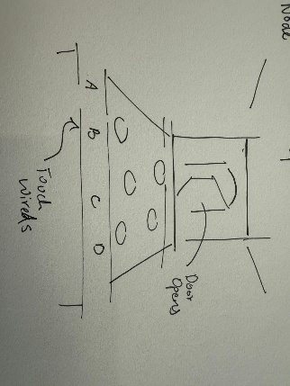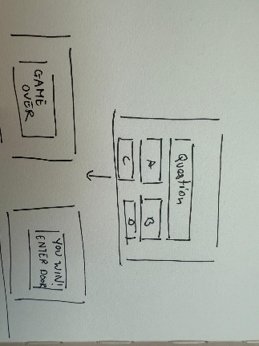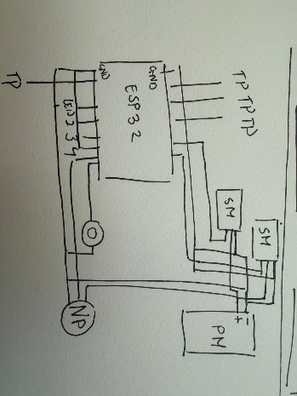

9. Final System Architecture (Labelled)
